# Homework for 15 Beetroot lesson “UI\UX. GUI”

## Beet Seed

### Протестуй UI/UX сайту Оксфорд Медикал. В Google docs створи 5 багів з дотриманням усіх вимог до оформлення багу + Додай результати кросбраузерного тестування до зафіксованих раніше багів

1. **OxfordMedical-1**

**Summary:** Discounts block above the menu on the homepage has misleading design comparing to general one of whole website.

**Priority:** 4 / **Severity:** 2

**Preconditions:** Access the website [https://oxford-med.com.ua](https://oxford-med.com.ua/)/

**Bug description:** Block with actual discounts information has orange background color, while the whole website design have three main colors: blue, green and white.

**Steps to Reproduce (STR):**

1. Navigate to the homepage of the website;
2. Observe the area above the menu;
3. Notice the information block with discounts seems to be misleading of general design of the website (small text and orange background color).

**Expected Result:**  
 The design of indicated block must match the general design colors.

**Actual Result:**

A block is visible above the menu that appears out of place, because of the orange background color.

**Demonstrating photo of bug (attachments):**

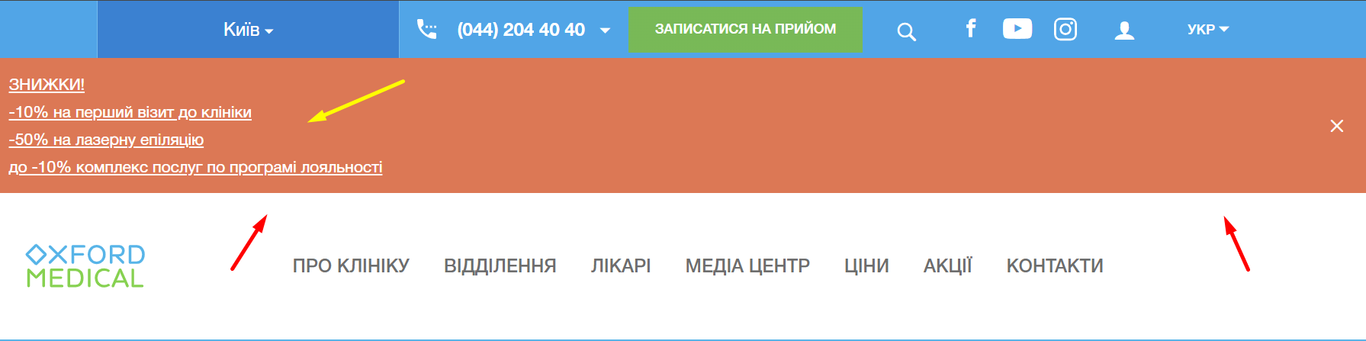

1. **OxfordMedical-2**

**Summary:** Text of one of the subblocks in the "Current Promotions" block does not fit within the designated area on the website’s homepage.

**Priority:** 2 / **Severity:** 2

**Preconditions:** Access the website [https://oxford-med.com.ua](https://oxford-med.com.ua/)/

**Bug description:** The “Current discounts” block on the general website page have subblocks with actual discount promotions, and one of the subblocks text doesn't fit in its block area.

**Steps to Reproduce (STR):**

1. Navigate to the homepage of the website;
2. Locate the "Current Promotions" block;
3. Focus on the sub-block containing the text "Check-up...".

**Expected Result:**

The text should fit properly within the square sub-block.

**Actual Result:**

The text overflows and does not fit within the square sub-block, that makes it not visible to the user.

**Notice:** Not actual for Mozilla Firefox, v. 133.0.3.

**Attachments:**

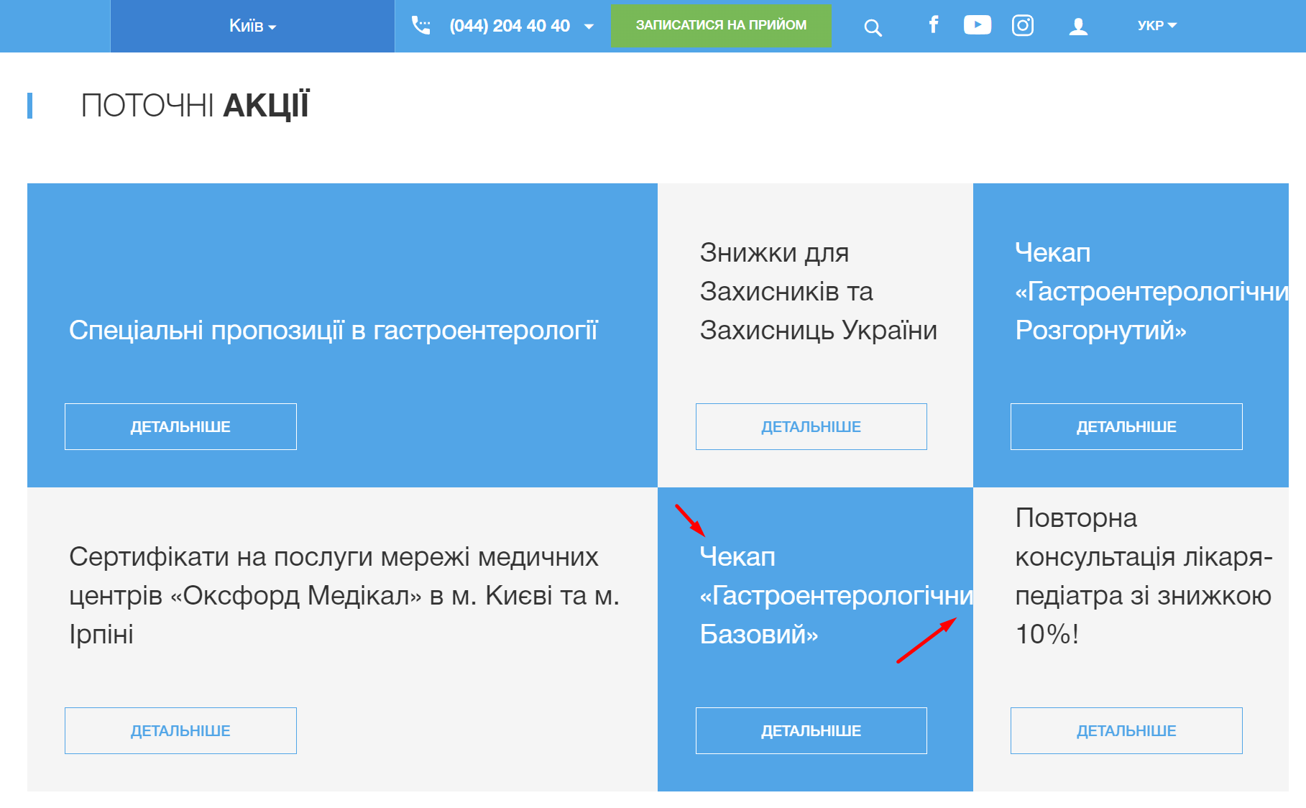

1. **OxfordMedical-3**

**Summary:** Text block is aligned to the right side in the "About the Clinic" website section.

**Priority:** 5 / **Severity:** 4

**Preconditions:** Access the website [https://oxford-med.com.ua](https://oxford-med.com.ua/)/

**Bug description:** General text section “About the clinic Oxford Medical” is aligned to the right side in the “About Clinic” menu section, while the global recommendations are advising to use the left side text align for the appropriate language.

**Steps to Reproduce (STR):**

1. Navigate to the "About the Clinic" section of the website, clicking appropriate button in the menu;
2. Observe the alignment of the text block.

**Expected Result:**

The text block should follow the global text formatting recommendations and to be left-aligned.

**Actual Result:**

The text block is incorrectly aligned to the right side.

**Attachments:**

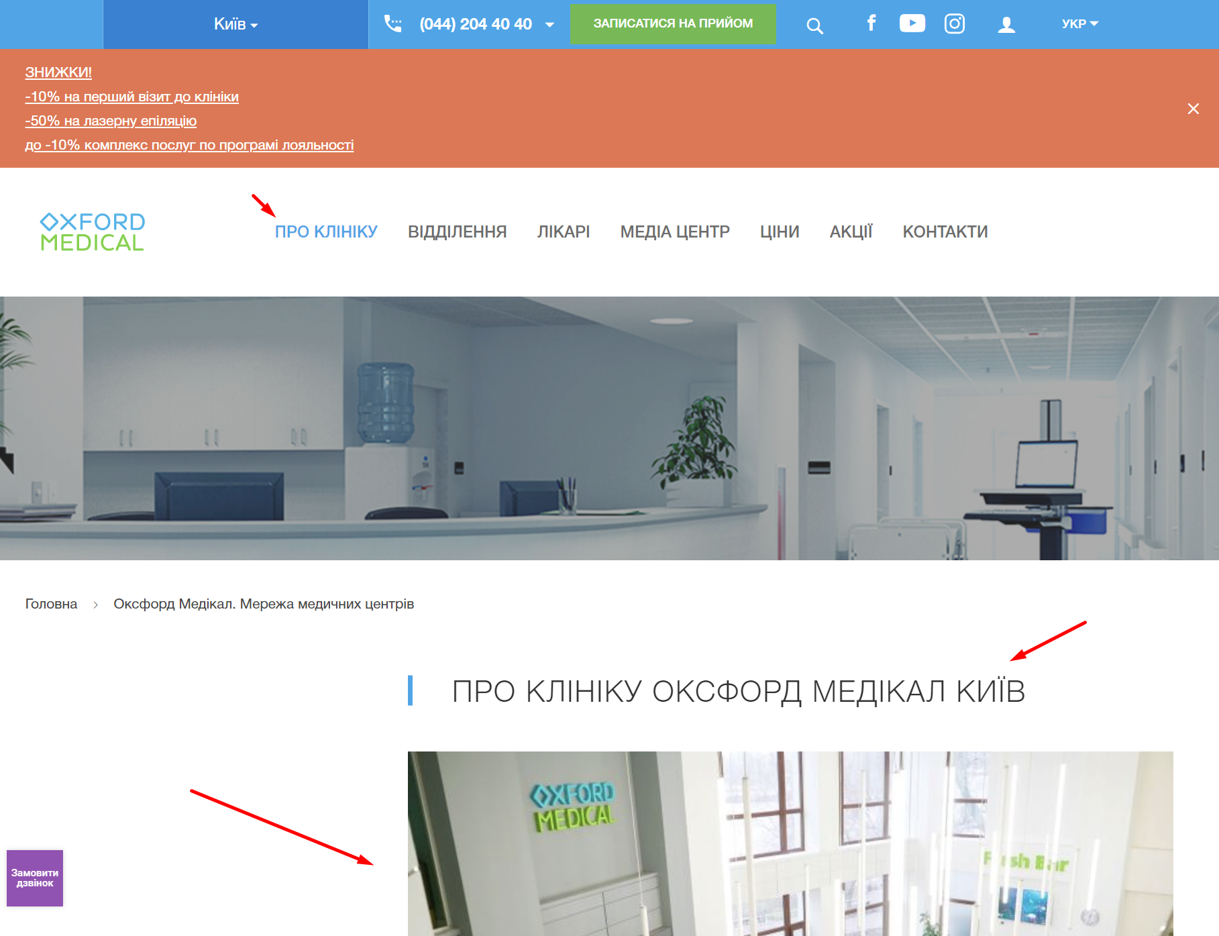

1. **OxfordMedical-4**

**Summary:** The "Contact Us" button displays two phone icons in the bottom-left corner.

**Priority:** 5 / **Severity:** 4

**Preconditions:** Access the website [https://oxford-med.com.ua](https://oxford-med.com.ua/)/

**Bug description:** Button which is responsible for the functionality of immediately contacting (have text “We are in touch and ready to help” and is located in the left bottom corner of the page) displaying two separate phone icons.

**Steps to Reproduce (STR):**

1. Navigate to general page of website;
2. Find "Contact Us" button that is displayed in the bottom-left corner;
3. Observe the icons displayed on the button.

**Expected Result:**

The button should display only one phone icon.

**Actual Result:**

The button displays two phone icons.

**Notice:** Not actual for Mozilla Firefox, v. 133.0.3.

**Attachments:**

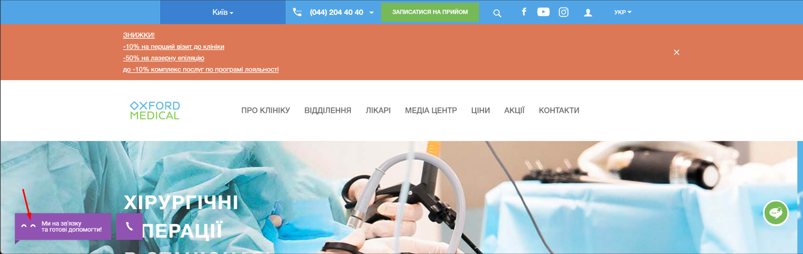

1. **OxfordMedical-5**

**Summary:** Operating hours block for "Ivan Kramsky Street" is misaligned to the right in the footer.

**Priority:** 4 / **Severity:** 3

**Preconditions:** Access the website [https://oxford-med.com.ua](https://oxford-med.com.ua/)/

**Bug description:** In the block with texts about clinic locations, working hours and contacts, one block is like misaligned to the right side and looks like an incorrectly formatted and “detached”.

**Steps to Reproduce (STR):**

1. Scroll to the footer section of the website;
2. Locate the block with operating hours for "Ivan Kramsky Street."

**Expected Result:**

The block should be aligned consistently with other blocks in the footer.

**Actual Result:**

The block is shifted to the right, unlike the others.

**Attachments:**

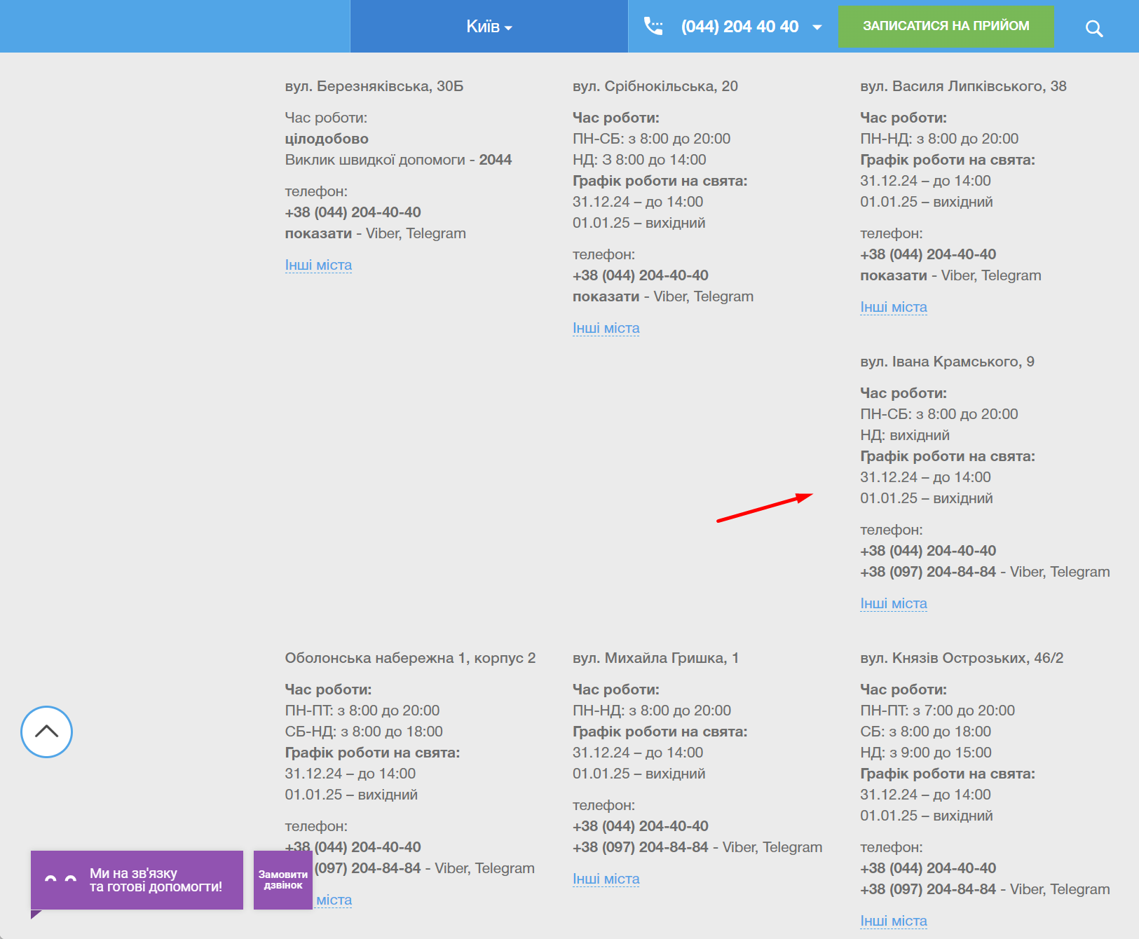

1. **OxfordMedical-6**

**Summary:** The "Instagram" button does not enlarge on hover in the social media section of the footer.

**Priority:** 5 / **Severity:** 5

**Preconditions:** Access the website [https://oxford-med.com.ua](https://oxford-med.com.ua/)/

**Bug description:** In the “Social Media” block, all the rounded buttons have a hover effect: if the user moves the cursor to the icon and holds it, the icon scales to larger, except for the “Instagram” button. It doesn’t have this effect, which is misleading to the general web page design.

**Steps to Reproduce (STR):**

1. Scroll to the footer section of the website;
2. Locate the "Instagram" button in the social media block;
3. Hover the cursor over “Facebook” and “YouTube” buttons;
4. Notice the animation of the elements;
5. Hover the cursor over the "Instagram" button;
6. Pay attention to the animation of the element.

**Expected Result:**

The button should enlarge on hover, consistent with other social media buttons.

**Actual Result:**

The "Instagram" button does not enlarge on hover.

**Attachments:**

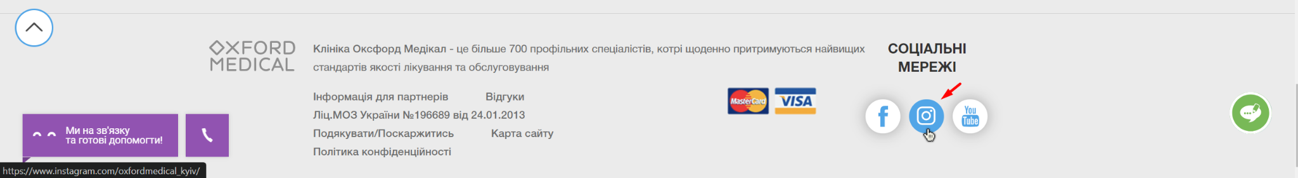

## Beet Sprout

### Проведи кросбраузерне тестування знайдених раніше багів у трьох різних браузерах

| **Browser & version →**  **Test Case № & Title ↓** | **Google Chrome** | **Mozilla Firefox** | **Microsoft Edge** |
| --- | --- | --- | --- |
| **v. 126.0.6478.251** | **v. 133.0.3** | **v. 131.0.2903.112** |
| **1. Discounts block above the menu on the homepage has misleading design comparing to general one of whole website.** | Actual | Actual | Actual |
| **2. Text of one of the subblocks in the "Current Promotions" block does not fit within the designated area on the website’s homepage.** | Actual | Not Actual | Actual |
| **3. Text block is aligned to the right side in the "About the Clinic" website section.** | Actual | Actual | Actual |
| **4. The "Contact Us" button displays two phone icons in the bottom-left corner.** | Actual | Not Actual | Actual |
| **5. Operating hours block for "Ivan Kramsky Street" is misaligned to the right in the footer.** | Actual | Actual | Actual |
| **6. The "Instagram" button does not enlarge on hover in the social media section of the footer.** | Actual | Actual | Actual |

## Mighty Beet

### За допомогою Developer Tools зафіксуй використаний шрифт, його розмір, колір та колір бекграунду елементів сайту Оксфорд Медикал

* **Номер телефону у хедері**

Шрифт: HelveticaNeue-Bold, sans-serif

Розмір шрифту: 14px

Колір шрифту: [rgb(109, 109, 109)](https://rgb.to/rgb/109,109,109)

Колір бекграунду: [rgb(248, 248, 248)](https://rgb.to/248,248,248)

* **Ім’я асистента при виклику чата допомоги**

Шрифт: Roboto, sans-serif

Розмір шрифту: 15px

Колір шрифту: [rgb(255, 255, 255)](https://rgb.to/hex/ffffff)

Колір бекграунду: [rgb(155, 79, 182)](https://rgb.to/hex/9b4fb6)

* **Кнопка “інші міста” у футері сайту**

Шрифт: Times New Roman

Розмір шрифту: 16px

Колір шрифту: [rgb(36, 167, 237)](https://rgb.to/hex/24a7ed)

Колір бекграунду: [rgb(248, 248, 248)](https://rgb.to/248,248,248)

* **Placeholder “ім’я” у формі “ЗАПИСАТИСЯ НА ПРИЙОМ”**

Шрифт: HelveticaNeue, sans-serif

Розмір шрифту: 14px

Колір шрифту: [rgb(109, 109, 109)](https://rgb.to/hex/6d6d6d)

Колір бекграунду: [rgb(255, 255, 255)](https://rgb.to/hex/ffffff)